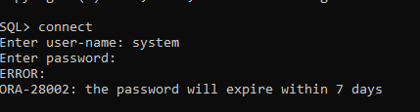

Решение
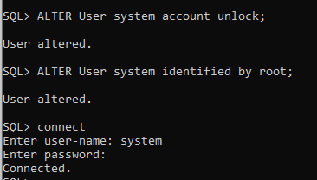

ALTER User system account unlock;
Alter User system identified by root;

